The french language

  - Element of culture report
Darcy Penny
taBLE OF contence
1.0 Introduction | 1
2.0 Origin of the French language | 1
3.0 Diffusion and dispersal of the French language | 2
4.0 Factors that facilitating in the diffusion of the French language | 2
4.1 Advancements in transport telecommunications | 2
4.2 Advancements in the role played by media | 3
5.0 Case Studies | 4
5.1 Quebec, Canada | 5
5.2 North and Western African Countries | 6
6.0 Implications of the changes in the Nature and Spatial Distribution of the French language | 7
6.1 Implactions in the nature of the French language | 7
6.2 Implactions in the special distribution of the French language | 8
7.0 Likely future changes in the nature and spatial distribution of French language | 8
7.1 Likely future changes to the nature of the French language | 8
7.2 Likely future changes to the special distribution of the French language | 9

1.0 Introduction
Culture is defined as the idea, customs, beliefs, and traditions of a specific group of people. The French language is incorporated into this group as the French language is a custom or tradition of specific places such as France. The purpose of this report is to inform you of how the French language has diffused, dispersed from its origin, how advancements in technology and media have influenced this, how the language has been resisted and/or embraced, and the positives and negative in the implications of the nature and spatial distribution along with the likely future changes in the nature and spatial distribution of the language.

2.0 – origin of the french language
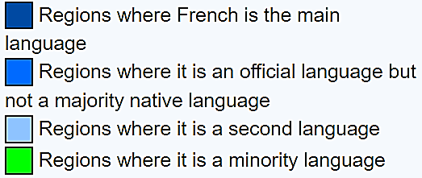
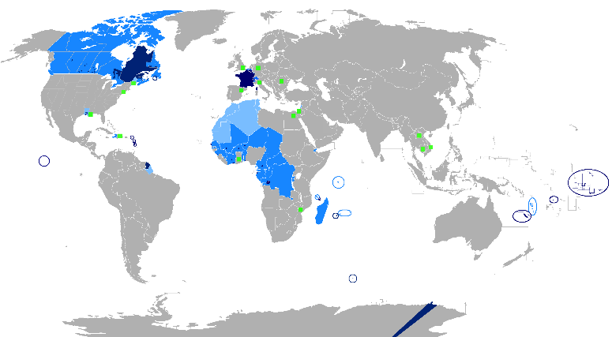
The French language originated from the Gaul language. In the 1st and 2nd centuries BC, Gaul was conquered by the Romans, and because of this the Gaulish language came under attack. As of this the Gaulish language faded, and the Latins took over. This caused the people to embrace the Latin language. During this transition, many words stayed the same and became the Latin language. As the Roman Empire expanded, Latin was carried through and across European regions and countries and within the transformation, the lower class were largely attributed. This caused Latin to become transmuted from its classical roots and have a new host of indigenous people to become a “language of the people.” As French grew as its own language, because it was distinct enough from Latin, the Latin roots were still there during the 9th century. Figure 1 states where French is spoken today.
Figure 1 – map where the French language is spoken

3.0 – diffusion and dispersion of the french language
The French language started off in only the country of France and now is the official spoken language in over 25 countries. These countries include France, Quebec, Madagascar, and Niger just to name a few. This is shown back up in Figure 1 on page 1.
In the 12th and 13th centuries, French became and gained the status of literary language because of both the political and cultural prestige of Paris.

4.0 Factors facilitating the Spread of the freNch LANGUAGE
Factors such as advancement in transport telecommunications and advancement is the roll played by the media have helped tremendously in the help of the facilitation of the French language.

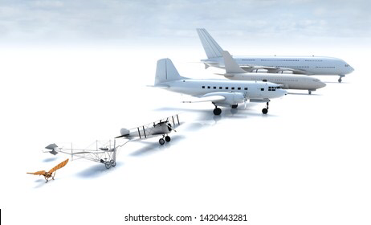
4.1 advancement in transport telecommunications
The advancement in air travel have allowed people to move from place of origin and around the country and across the world. This has caused languages to be expressed all over the world such as the French language. The advancements in air travel has also allowed help in World War II which helped the French to take over countries and spread the language. This caused the French language to take over countries in North and Western parts of Africa over time. Figure 2 shows the evolution of airplanes.
Figure 2 – Evolution of airplanes

Another advancement in transport telecommunications is the advancement in Railways. Figure 3 states the different types of railway vehicles used today. Railways has allowed easy and cheap access and interconnection to surrounding countries with France. This has made cheap, quick transport of good, services and people across boarders. This helps people to express their culture and language with surrounding countries and people from the other sides of the country. This is shown as the French language has spread more rapidly from the Quebec, Canada to other parts of Canada more quickly.
Figure 3 – Shows the different types of trains

4.2 the rolls played by media
The increase popularity of the media has drastically increase the French language. Media methods such as social media, press papers, print media, television, and google websites all contribute to the distribution of the French language. Figure 4 shows other types of media that the French language can be distributed from.
Television programs can be a good my to distribute the French language as some of these programs can be in the French language. Other television programs such as news can have interviews from people who speak the language. This caused large exposure to people.
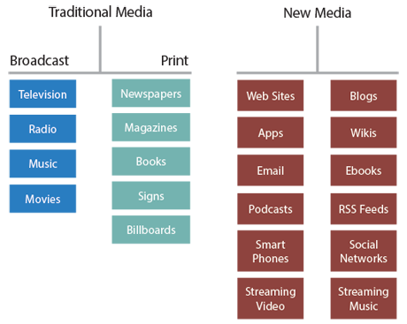
Print media and cinematography productions is another way that helps the distribution of the French language. This way, people can read what is happening in places that speak the language and also be expressed and exposed to the language and the culture. Movies can use french language with in them to create different scenes and maybe to create jokes for people to enjoy. This way they are exposed to the language and with this exposure the distribution of the language continues.
Figure 4 – Different types of media
Press media is another way that the French language is exposed to people. News reports can have the language incorporated with in them to prove a point or to have evidence against a report. As stated before, television programs such as news can have interviews from people who speak the language.
Lastly, social media and media platforms help with the distribution of the French language by having contact with one endothermic at any given time is ever increasing thanks to modern technology. Large numbers of different cultures are expressed on man different media platforms for all who sign up can see them such as YouTube and Instagram.

5.0 – case studiEs on the embracement of the fRench language
The French language was both refused and embraced in many places. Mainly, the French language was embraced in Quebec, Canada. Other places, as in North and Wester Africa, such as countries like Niger and Guinea have also embraced the Language.

5.1 – Embracement of the French language in Quebec, Canada.
Figure 5 shows where French is spoken today.
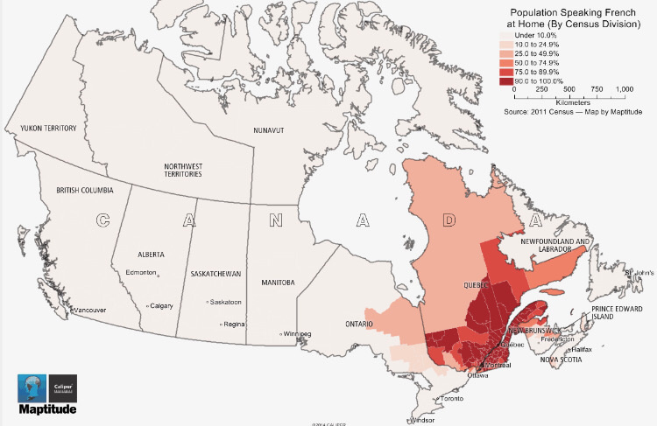
In 1534, the first of the French presents was in Canada, even though permanent settlement didn’t come to the Quebec City until 1608, by Samuel de Champlain. The French language crept quickly across Canada from as far as east as the Maritime Provinces and as south to the Gulf of Mexico.
French Canadians became a distinct cultural group, under British rule, in 1763 by the formation of the Treaty of Paris. This was formed due to the France’s defeat in the French and Indian wars. The treaty of Paris also caused Britain to gain control over New France.
Figure 5 – Shows the population Speaking French at home
In 1867, French Canadians accounted for more than one-third of the country’s population. This was due to the establishment of the Dominion if Canada.
Finally, in 1974, Quebec’s recolonized that French was Quebec’s new official language. There was a Growing demand for political autonomy in Quebec after the World War II. Not long after, the Parti Québécois became in power in the province of 1976. The political independence proposal came to rest in 1980 after the Canada was defeated by the Polls. However, the separatism of French Canadian remained a massive issue, not only for the province but as a notion as a whole.
6.5 million of People Living in Canada, represents about one quarter of the total population of the country, actually speak French Canadian. 5.1 Million of those live in the province of Quebec. Because of this, French Canadians are the largest group of French speakers in North America. Majority of these French Canadians are actually Roman CATHOLIC. Until the mid-1960’s, the church was the center to French Canadian life, but today the French Canadian community has become secular, and church ATTENDANCE has declined and decreased along with the influence of the church on daily lives.
5.2 – embracement of the french language in the NoRth and western Countries of Africa.

French is present in most parts in North and Western parts of Africa. These countries include Mauritania, Senegal, French Sudan (now Mali), French Guinea (now Guinea), Côte d’Ivoire , Upper Volta (now Burkina Faso), Dahomey (now Benin) and Niger. This was due to the French West Africa federation of eight French colonial territories. While this was happening, a mission was sent to conquer the Chad Basin and all French territories in West Africa in 1898, sent from Senegal.
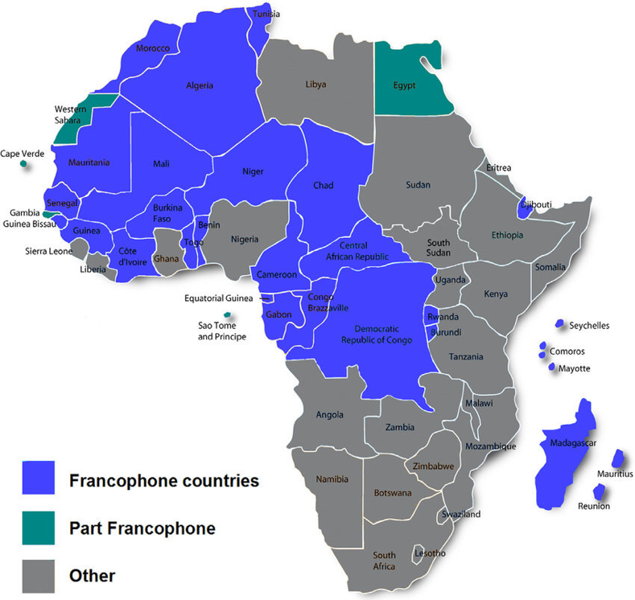
In the late 1890’s, the French government sent a rein in territorial expansion to transferal territories west of the Gabon to a single based governor in Senegal. Mainly to directly report to the Minister of Overseas Affairs.not long after in 1895, the first governor general of Senegal was named. In 1904, he oversaw the territories that were formally named French West Africa (AOF). Gabon later became the seat of his own federation, the French Equatorial Africa (AEF). This would boarder the west sides of the Chad and Niger modern boarder.
Figure 6 – Map of where French is spoken in Africa
The French invasion of Algeria, 1830, was the beginning of the French North Africa. This was the heights of French colonial control. From 1848, when french officially made Algeria its own colony, until Independence in 1962, the whole Mediterranean region of Algeria was administered as an intergalactic part if France.
During the collapse of the Ottoman Empire at the hand of the Russians, the French protectorate of Tunisia was established in 1881 and continued until the Tunisian independence in 1956. During this time, there was many improvements undertaken such as transport and infrastructure, industry, the financial system, public health, and administration, although French businesses and citizens were favored, even though there was much anger and resentment to he Tunisians.

6.0 – IMPLICATIONS of the changes in the nature and SPATIAL DISTRIBUTION of the french language
There are many implications with the French language. These are positive and negative, in terms of the nature ( Characteristics ) and the spatial distribution of the French language.

6.1 – nature
The positive in the nature of the French language is that it, is a world language. With this, people speak the language and preserve the culture it brings. The French language also brings jobs. Such as, translations jobs, tour guides, flight attendance, and publication and publishing jobs, this includes editing.
This the positives, there is also negatives about the language. The main negative about the language is that it is hard to understand and learn from a strong English speaker. This includes trying to understand French speakers accents when speaking English. Other negatives about the nature of the language is that, translation to other languages is costly and time consuming. Trade becomes difficult when the TransNational corporation is English based speaking. Opportunities become costly in money and time, in terms of universities and exchange programs as people need to learn the language to be successful in this space.
6.2 – spatial DISTRIBUTION
The positives about the spatial distribution of the French language is that the language does become sacred and protected in places such as Quebec and France.
However there is many more negatives. The language is taught less in schools as schools are now teaching more foreign and European language such as Indonesian. The language is becoming less common and less dominant. There is more travel implications such as you will need to learn French when traveling to France and Quebec to be able to understand what people are asking and what you are asking of other people in those countries.

7.0 – likely future changes in the nature and spaTIal DISTRIBUTION of tHe french language
There are many implications with the likely future changes in the French language. As said before, these are positive and negative, in terms of the nature ( Characteristics ) and the spatial distribution of the French language.

7.1 – nature
With the likely predictions of the French language, the French language is expected to become the most widely spoken mother tongue language in Europe by 2025. The negatives, however, include to be taken over by the English language, further be influenced by English, Italian and Greek to the point where that language is no-existent. The language is expected to become more English based and conflicted by Greek and English.

7.2 – spatial DISTRIBUTION
The spatial distribution of the French language is expected to be come very sacred in places such as France and Quebec. It is also predicted to be be taken over by either the English, Greek or Italian languages. Is is becoming small and less spoken in places as it is taught less in schools. This is caused by schools changing these languages to more European languages and more foreign languages such as Indonesian. Travel implications such as less movement due to COVID-19 has caused the language to be distributed less through out the world.

